Lab ELB:

Step 1 : Create 2 EC2 instances with nginx server webserver installed

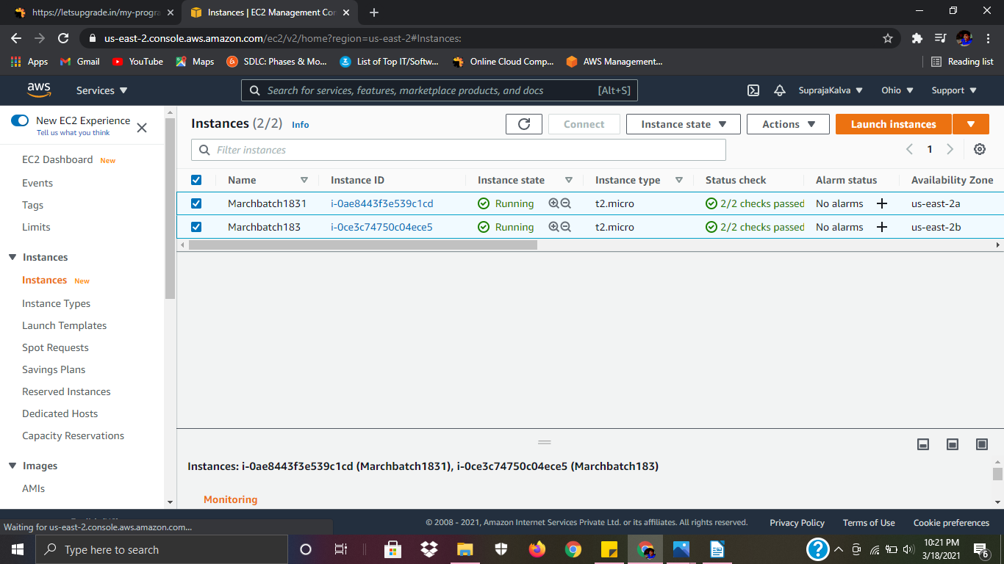

Step 2: Add instances to ELB target group

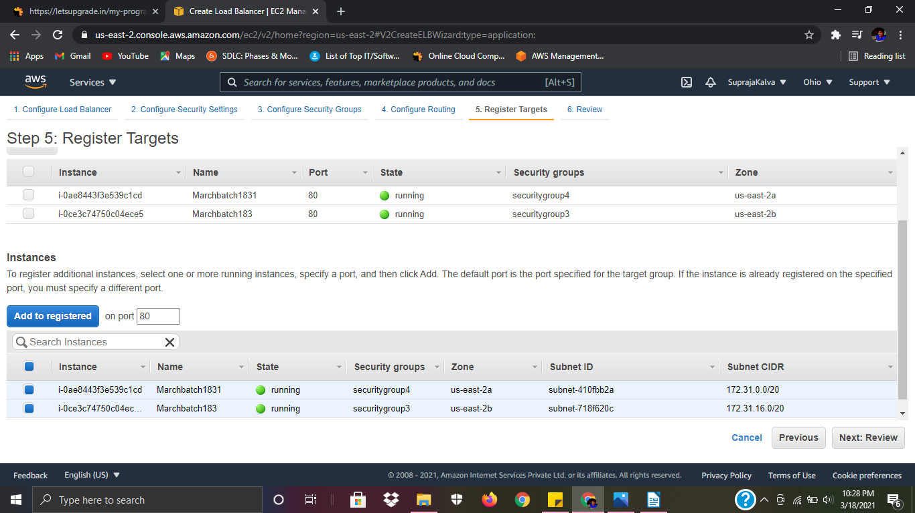

Step 3:

Created an Elastic Load Balancer

